Nincompoop Project: Images
Name | SLSA | High Res Image Avail | Image
Charles Cameron Kingston | B 1848 |  | 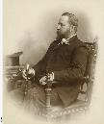
Colonel William Light | B 6704 |  | 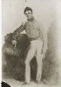
Edward Gibbon Wakefield | B 63785 |  | 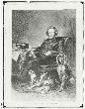
George Gawler | B 5982 |  | 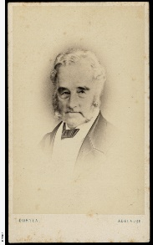
Henry Ayers | B 10797 |  | 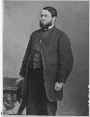
John Hindmarsh | B 11165 |  | 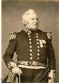
Robert Gouger | B 48189 |  | 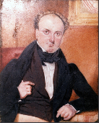
Sir Robert Richard Torrens | B 8411 |  | 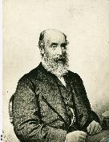
Sir George Grey | B 7331 |  | 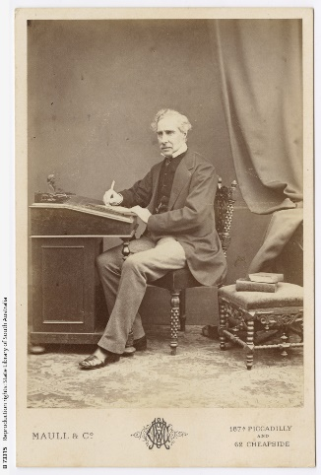
Sir John William Jeffcott | B 464 |  | 