The Nincompoops

according to Mary Lee

Charles Cameron Kingston

1850 - 1908
Charles Cameron Kingston
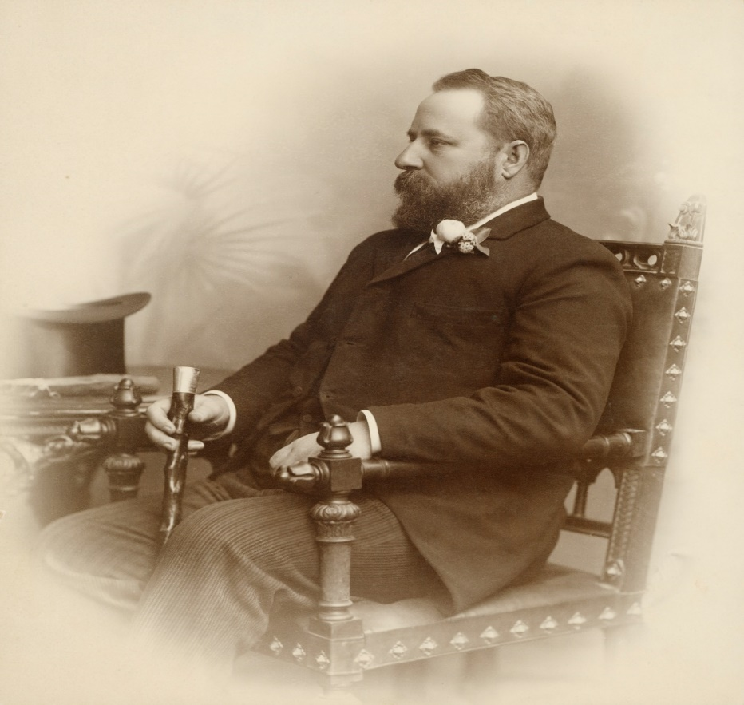
Famous because:
Kingston was premier of South Australia from 1893-1899. He held the longest serving ministry in South Australia at the time.

Behind the scenes:
Prior to becoming a politician, Kingston was a lawyer. He was the Attorney General in Sir John Colton’s ministry (June 1884-June 1885) and in the first Playford ministry (1887-1889).

In 1892, Kingston challenged a conservative member of the Legislative Council (Sir Richard Barker) to a duel on 23 December, in Victoria Square. Barker informed the police who arrested Kingston upon his arrival at Victoria Square. Kingston was subsequently charged, tried and ‘bound over to keep the peace for 12 months’. The sentence was still in force when he became premier in June 1893.

When Kingston won the election in 1893 he opposed the female vote but was persuaded that votes for women could be politically advantageous. According to Crowley , ‘there are grounds for suspecting that women’s suffrage was introduced in South Australia…not so because [he was] passionately interested in women’s rights as because [he] calculated that the number of women in [the colony] lived in those areas which [he] received the strongest support.’ When the vote was won, ‘Kingston got the credit, women got their votes, but no woman member ever graced the local parliament. South Australia was thus able to enter federation with a refurbished progressive reputation’.

Kingston was a liberal-democrat and was idolized by the working class.

His body was exhumed in Adelaide in 2008 at the request of an Adelaide businessman and his sister who believed they were related to one of the ‘illegitimate’ children fathered by Kingston. The DNA tests proved this to be the case.

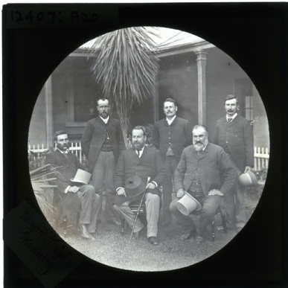  Kingston’s Ministry (approximately 1893) | Commemoration:  - Bronze statue in Victoria Square  - Bust held in Parliament House, Adelaide  - Electoral Division: Kingston

References
Primary sources
- The Express and Telegraph (Adelaide SA: 1867-1922) (1992), ‘That duel: Kingston and Baker episode’, Thurs 29 Dec 1892, p 2 https://trove.nla.gov.au/newspaper/article/208446988 accessed online 28 Aug 2018.

- Adelaide Observer (SA: 1843-1904), Sat 31 Dec 1892, page 24, https://trove.nla.gov.au/newspaper/article/160801859 accessed online 28 Aug 2018.

- The Mount Barker Courier and Onkaparinga and Gumeracha Advertiser (SA: 1880-1954) (1892), ‘The Barker-Kingston duel’, Fri 30 Dec 1892, page 3. https://trove.nla.gov.au/newspaper/article/147624775 accessed online 28 Aug 2018

- Guardian (2008), ‘Body exhumed after century in paternity case’, The Guardian, 27 May 2008, https://www.theguardian.com/world/2008/may/27/australia accessed online 28 August 2018

- M. Owen (2010) DNA tests prove link to federation father’, The Australian, May 12, 2010 https://www.theaustralian.com.au/news/nation/dna-tests-prove-link-to-federation-father/news-story/3128578ce6747813ac57ffdfaf167059 accessed online 28 August 2018.
Secondary sources
- F. Crowley (1974), A New History of Australia, William Heinemann Australia, Victoria.

- P.A. Howell (1986), ‘Constitutional and political development, 1857-1890’, in D Jaensch (ed) The Flinders History of South Australia, Political History, Wakefield Press, Adelaide.

- D. Pike (1967), Paradise of Dissent, South Australia 1829-1857, 2nd ed, Melbourne University Press, Victoria.

- J. Playford (1983), Kingston, Charles Cameron (1850-1908), Australian Dictionary of Biography, National Centre of Biography, Australian National University, http://adb.anu.edu.au/biography/kingston-charles-cameron-6966 published first in hard copy 1983, accessed online 28 August 2018.

Charles Cameron Kingston SLSA [B1848]
Howell (1986)
Playford (1983)
Playford (1983)
Playford (1983); See also Trove newspaper references
The reason for this was because it would increase the power of the Legislative Council, which he, like his father, wanted to abolish. Pike (1967), p 485
Crowley (1974), p 245
Pike (1967), p 485
Pike (1967), p 483
Crowley (1974), p. 239
See https://www.theguardian.com/world/2008/may/27/australia; https://www.theaustralian.com.au/news/nation/dna-tests-prove-link-to-federation-father/news-story/3128578ce6747813ac57ffdfaf167059
‘C.C. Kingston’s Ministry’ SLSA [B12407] https://collections.slsa.sa.gov.au/resource/B+12407

