The Nincompoops

according to Mary Lee

Colonel William Light

1796 - 1839
Colonel William Light
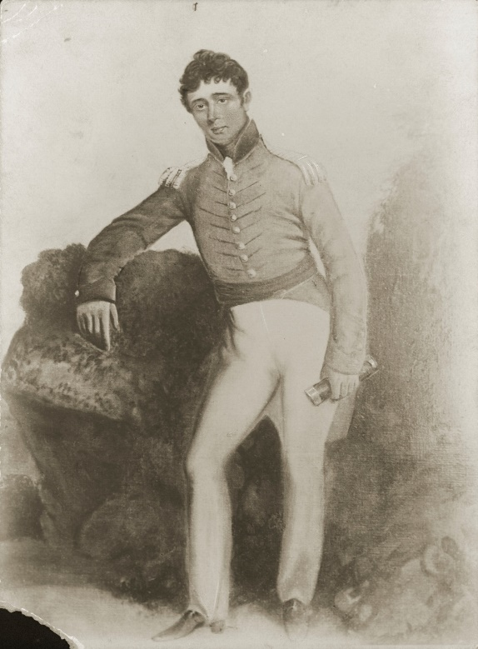
Famous because:
Light was the first Surveyor-General of South Australia and was responsible for selecting the site of Adelaide as the colony’s capital. He was led to the site by an Aboriginal man named Mullawirraburka.
Behind the Scenes
Light was born in Malaya and went to England at 6 years of age. His father was a naval officer who worked for the East India Company. There are claims that his mother was a Malaysian princess (a daughter of the Sultan of Kedah).
Light arrived off Kangaroo Island in 1836. Some of the hurdles he faced in selecting the site for the city of Adelaide and survey the land include:
Poor staffing in terms of numbers and experience. Light’s deputy was George Strickland Kingston who knew little about surveying and perhaps because of this, some staff selected by Kingston were not suitable.
Inadequate equipment and no provisions for transport. For example, no horse or pony to carry their equipment.
Constant interference by Hindmarsh in survey matters and the location of Adelaide. This is despite the fact that Light had exclusive authority to select and survey the settlement, and to determine the site of the capital city.
Light resigned in 1838 for several reasons:
Commissioners refused to increase staff and the continuing flow of immigrants strained the capacity of his survey team.
Friction between Light and Hindmarsh.
To begin his own private business.
Light died of ill health on 10 Oct 1839 in his cottage at Thebarton and his remains were buried in Light Square.
Commemoration:
- Statue on Montefiore Hill overlooking the city. Original sight was at Victoria Square. Moved to Montefiore Hill in 1939
- Light Square
- Colonel Light Gardens (suburb of Adelaide)
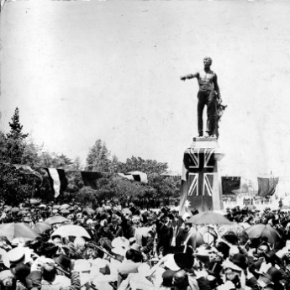  Unveiling the Colonel Light Statue in Victoria Square (approximately 1906). | 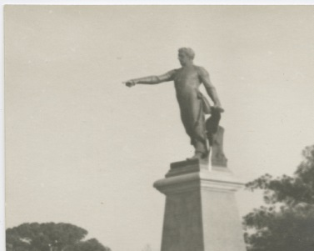  Statue of Colonel Light at Montefiore Hill (approximately 1938).

References

Primary sources
- Border Watch (Mount Gambier; SA: 1861-1954), ‘Founded city in which he died broken hearted’, Thus 26 Oct 1939, p 5 https://trove.nla.gov.au/newspaper/article/78156909

- Glenelg Guardian (SA: 1914-1936), ‘Lives of prominent men’, Thurs 25 Jan 1923, p 2, https://trove.nla.gov.au/newspaper/article/214721540

- Adelaide Observer (SA: 1843-1904), ‘Colonel Light’, Sat 1 Jan 1887, p 39, https://trove.nla.gov.au/newspaper/article/160755011
Secondary sources
- D. F. Elder (1984), William Light’s Brief Journal and Australian Diaries with an Introduction and Notes by David Elder, Wakefield Press, Adelaide.

- D. F Elder. (1967), ‘Light William (1786-1839’), Australian Dictionary of Biography, National Centre of Biography, Australian National University, http://adb.anu.edu.au/biography/light-william-2359 published first in hardcopy 1967 accessed online 27 March 2018.

- J. M. Maine (1986) ‘The foundation of South Australia’ in D. Jaensch (ed) The Flinders History of South Australia, Political History, Wakefield Press, Adelaide.

- A Grenfell Price (1929; 1978), Founders and Pioneers of South Australia, Mary Martin Books, Adelaide.

- I. Radbone and J. Robbins (1986) ‘The history of the South Australian Public Service’ in D Jaensch (ed) The Flinders History of South Australia, Political History, Wakefield Press, Adelaide, pp. 448-474.
Videos
Tarndanya AR https://vimeo.com/271808803

Colonel William Light SLSA [B6704]
Elder (1984)
Tarndanya AR https://vimeo.com/271808803
Elder (1984), p 24
Pike (1967), p 174
Hindmarsh wanted the capital at Encounter Bay or Port Lincoln
Main (1986), p 13
Radbone and Robbins (1986), p 449
‘Unveiling the Colonel Light Statue Victoria Square Adelaide’ SLSA [PRG280/1/13/358] https://collections.slsa.sa.gov.au/resource/PRG+280/1/13/358
Colonel Light’ SLSA [PRG287/1/5/85] https://collections.slsa.sa.gov.au/resource/PRG+287/1/5/85

