The Nincompoops

according to Mary Lee

Edward Gibbon Wakefield

1796 - 1862
Edward Gibbon Wakefield
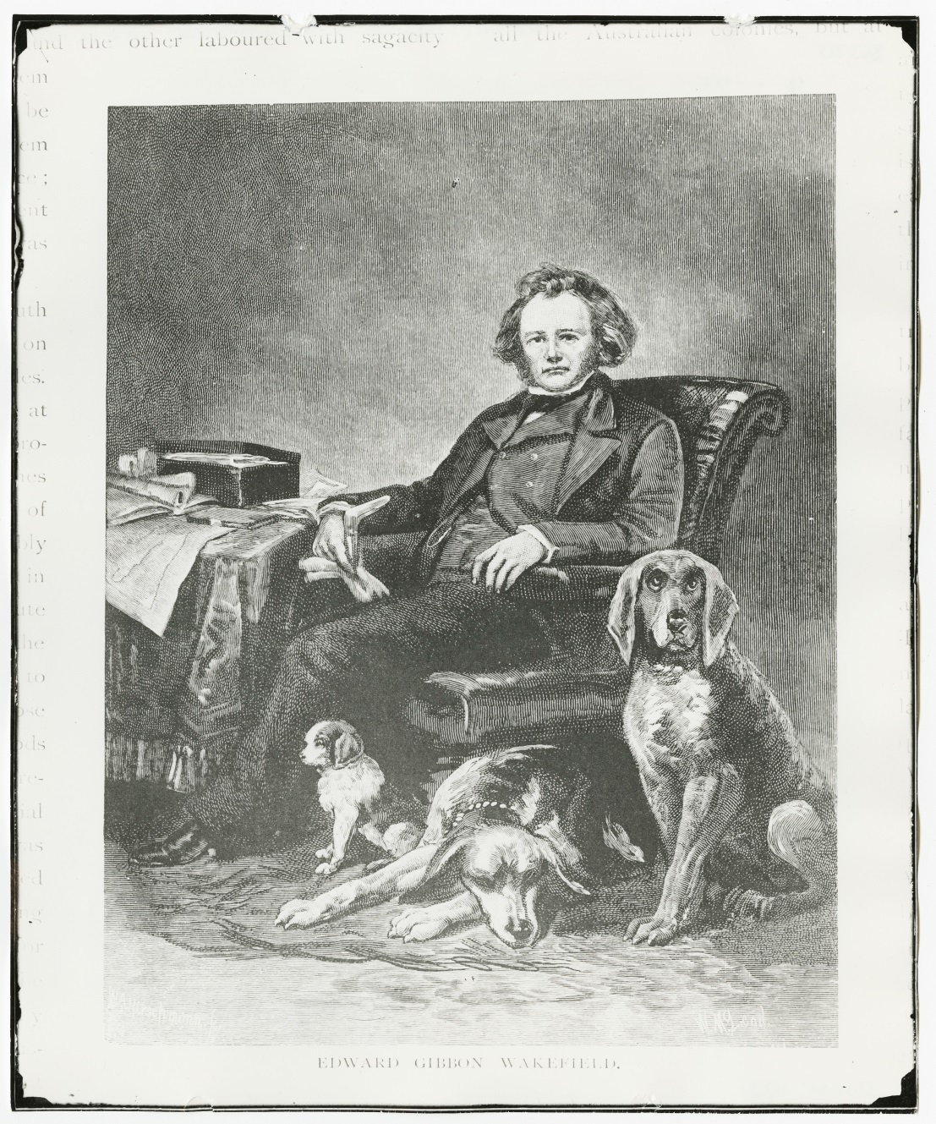
Famous because:
- Wakefield is considered the chief architect of South Australia because he developed the idea of ‘systematic colonisation’ which underpinned the colonisation of South Australia . His plan was to create a self-supporting, convict free colony. Land would be sold to pay for the emigration of free labourers and after working a few years, the emigrant labourers would be in a position to buy their own land and finance a new supply of labourers. The sale of land would be sufficient to prevent the emigrant labourer from buying land too soon after arrival. Emigrants would also be carefully selected with an equal proportion of sexes with a preference for young married couples.
Behind the scenes:
Wakefield was jailed in Newgate Prison for 3 years (1827-1830) for adducting and marrying a 15 year old heiress. While in jail, he came up with his ideas on systematic colonisation.
Wakefield was aided largely by Robert Gouger and Anthony Bacon who were also in prison at the time for debt and learned much about southern coast of Australia from fellow prisoner, Captain Henry Dixon.
Most of the important works on systematic colonisation were written anonymously but Wakefield incorrectly claimed to have written all of them. ‘He made plans, but…most of the detailed work was done in his absence and without his help. Some promoters were unaware of his existence, while those who most often sought his advice were most familiar with his silence.’
The practical application of Wakefield’s ideas did not live up to expectations. He ‘did not foresee that when the prudent labour, having saved his money, came to purchase a section of wasteland, he would find himself competing for emigrant workmen against the employer he had just left. In practice the emigrant worker would have to simultaneously beget and rear a large family and to save, in order that when his savings bought land his progeny would help him work it…committing Wakefield’s emigrants to the inescapable bondage of agricultural serfdom’.
The warrant for Wakefield’s arrest was bought by the National Museum of Australia in 2012. Wakefield never set foot in Adelaide. Senator Christopher Pyne wants the name of his electorate (Division of Wakefield) changed because of Wakefield’s tainted past.
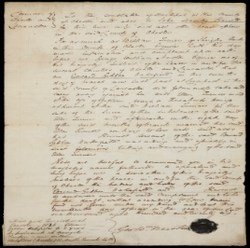  Arrest warrant issued for Wakefield in 1826 Image Sam Birch National Museum of Australia | 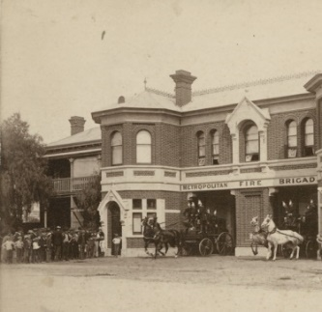  Wakefield Street Adelaide (approximately 1892)

References

Primary sources
- The Western Australian (Perth, WA: 1879-1954), ‘Bold abduction. The early career of E G Wakefield’, Sat 23 May 1936, p.4 https://trove.nla.gov.au/newspaper/article/40718754 accessed online 3 April 2018.

- Daily Examiner (Grafton NSW 1915-1954), ‘Edward Gibbon Wakefield’, Sat 23 Jan 1937, p.4 https://trove.nla.gov.au/newspaper/article/194406418 accessed online 22 August 2018.

- Blyth Agriculturist (SA: 1908-1954) ‘Edward Gibbon Wakefield’, Fri 25 March 1938, p. 4 https://trove.nla.gov.au/newspaper/article/215941484 accessed online 22 August 2018.

- State Library of South Australia Collections https://collections.slsa.sa.gov.au/resource/B+7399
Secondary sources
- D. Elder (1984) William Light’s Brief Journal and Australian Diaries with an Introduction and Notes by David Elder, Wakefield Press, Adelaide.

- J. M. Maine (1986) ‘Chapter 1 The foundation of South Australia’ in D Jaensch (ed) The Flinders History of South Australia, Political History, Wakefield Press, Adelaide, pp1-25.

- D. Pike (1967), Paradise of Dissent, South Australia 1829-1857, 2^{nd (}ed), Melbourne University Press, pp 74-95.

- G. L. Pretty, 'Wakefield, Edward Gibbon (1796–1862)', Australian Dictionary of Biography, National Centre of Biography, Australian National University, http://adb.anu.edu.au/biography/wakefield-edward-gibbon-2763/text3921 first published in hardcopy 1967, accessed online 21 November 2017.
Websites
- National Museum of Australia 2014, The People and Environment Blog The Scandalous Mr Wakefield, December 2, 2014, Accessed on line 3 April 2018 https://pateblog.nma.gov.au/2014/12/02/the-scandalous-mr-wakefield/

Edward Gibbon Wakefield SLSA [B63785]
Elder (1984), p 23
Maine (1986); Pike (1967)
https://trove.nla.gov.au/newspaper/article/215941484
Elder (1984), p 23
Pike (1967), p 78
Pike (1967), p 81
https://pateblog.nma.gov.au/2014/12/02/the-scandalous-mr-wakefield/
http://www.abc.net.au/news/2018-06-14/christopher-pyne-supports-changing-name-of-seat-of-wakefield/9866056
Image Sam Birch National Museum of Australia https://pateblog.nma.gov.au/2014/12/02/the-scandalous-mr-wakefield/
Wakefield street Adelaide SLSA [B7399] https://collections.slsa.sa.gov.au/resource/B+7399

