The Nincompoops

according to Mary Lee

George Gawler

1795 - 1869
George Gawler
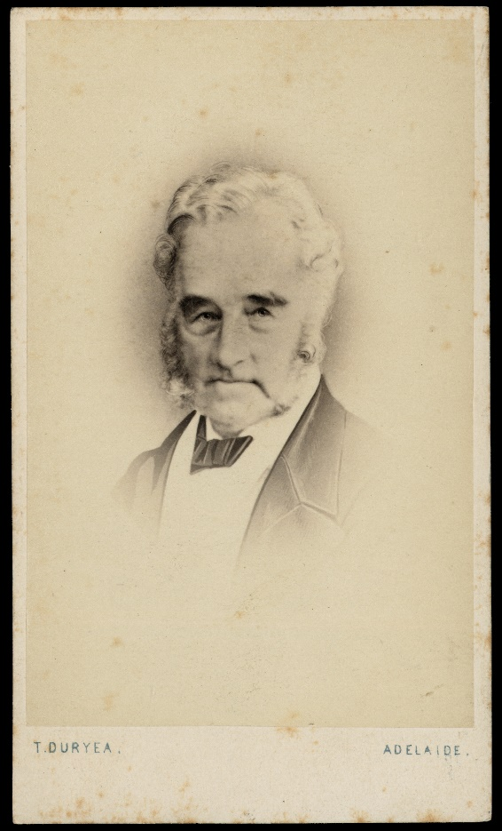
Famous because:
Gawler was the second governor of South Australia (October 1838 – May 1841).
Behind the scenes:
When he came to office in 1838, Gawler found the authorised expenditure for the colony had been surpassed, that the colonial treasury was empty; surveys were in arrears and inefficient, factious and/or underpaid public officers. To rectify this situation, he acted on his own authority and committed funds to public works.
He replaced most senior officers with professional administrators and increased the salary of civil servants to boost morale and devotion to duty. He also ensured that the Survey Department was adequately staffed and supplied with sufficient equipment and stores.
Gawler encouraged extensions of public works which contributed the financial crisis of 1841. ‘Though Gawler was well aware of the high profits made by speculators he was increasingly unable to persuade them to accept responsibility for works of public utility.’ Although Gawler was criticized for his lavish/extravagant expenditure, he did leave the administration of the colony much better than he found it.
In 1839, to prove his friendly intentions towards Aboriginal people, Gawler invited Aboriginal people from the Adelaide regions to a dinner in the grounds of Governor House to celebrate Queen Victoria’s birthday.

The Maria debacle:
‘It would seem likely that amongst Australia’s colonies South Australia would have effective rule of law because unlike other colonies in Australia, a clear judicial system was established almost from the beginning.’ This was not to be the case:
In 1840, a ship called Maria became shipwrecked on the south coast of Adelaide and the 26 survivors were murdered while attempting to return overland to Adelaide. Gawler was faced with the unprecedented task of putting the legal status of Aboriginal people, beyond the settled districts, to the test. The legal advice he was given by Chief Judge Cooper was that the court had no jurisdiction over Aboriginal people whom had no contact with Europeans. Further, ‘being unable to take an oath, Aboriginal evidence would be inadmissible in any case that might go to trial; and in the absence of survivors, there was no European evidence’ . Based on this, Gawler instructed Major Thomas O’Halloran, a former military man to find and hang the suspects, or shoot them on the spot. (Judge, jury and executor). Two Aboriginal people were subsequently hung and witnessed by other members of the ‘tribe’. Major O’Halloran is reported to have said, ‘Black men, this is white man’s punishment for murder. Let none of you take the bodies down. They must hang till they fall to pieces.’ A watercolour by E. C. Frome, depicting the hanging in 1840, is located in the Art Gallery of South Australia. When Frome came across the event 7 weeks later, the corpses were still hanging.
Gawler’s justification for the execution of the Aboriginal men without trial was questioned by several quarters. For example, the Crown Law Officer in Britain was of the view that Gawler and O’Halloran acted illegally, and liable to be tried for murder. The Aboriginal Protection Society in England also met and condemned Gawler’s actions. The editor of the Register, George Stevenson questioned the legality of Gawler’s actions.
‘Gawler began his governorship of South Australia with the determination to maintain peaceful relations between the colonist and the Aborigines of the province, yet with the Maria affair, his term ended in controversy and some degree of shame.’
It was Gawler’s over expenditure that led to his dismissal, rather than his action in the Maria debacle.
Why he come to South Australia:
‘His reputation for gallantry in the field, intellectual attainment and sincere piety all gave promise that he would soon bring order to the colony’s political chaos.’
Commemoration:
- South Australian country town, street in the city, building on North Terrace
- Gawler Ranges
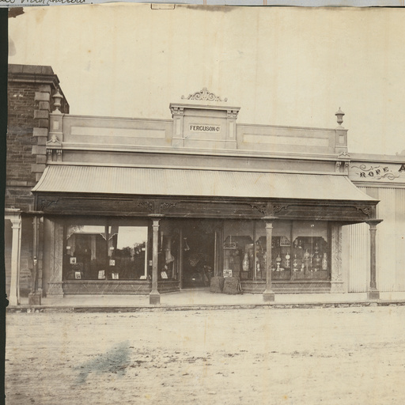  Gawler (approximately 1877) | 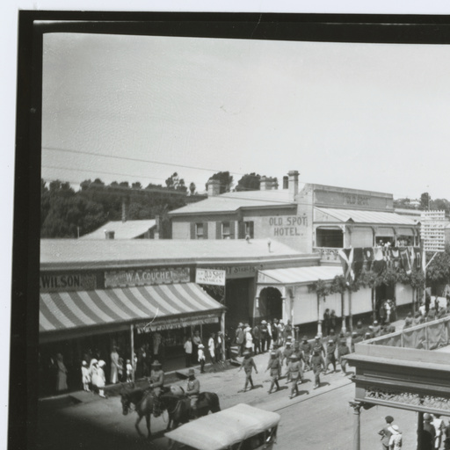  Gawler (approximately 1916)

References

Primary sources
- South Australian Register’ (Adelaide SA 1839-1900) ‘A parting word on the press’, Sat 28 Nov 1840, p2, Accessed online https://trove.nla.gov.au/newspaper/article/27442064 accessed online 1 May 2018

- Southern Argus (Port Elliot SA 1866-1954), ‘Colonel George Gawler’, Sat 14 August, 1869, p 4 https://trove.nla.gov.au/newspaper/article/96872974 accessed online 10 April 2018

- News (Adelaide, SA: 1923-1954), ‘The Maria Massacre - and a lost treasure’, Sat 21 Feb 1942, p 5, https://trove.nla.gov.au/newspaper/article/131950481
Secondary sources
- B. Attwood (2003), ‘Historiography on the Australian frontier’ in Frontier Conflict the Australian Experience, (eds) B Attwood & S G Foster, National Museum of Australia, p 179.

- R. Foster and A. Nettlebeck (2012), Out of Silence: The History and Memory of South Australian Wars, Wakefield Press, Adelaide, pp 25-32. https://books.google.co.uk/books?id=r9ETLG_aKbkC&pg=PA32#v=onepage&q&f=false

- R. M. Hague, H. Whitington (2005), Hague’s History of the Law in South Australia, Volume 1, Barr Smith Press, University of Adelaide.

- R. Hetherington (1966), Gawler, George (1795-1869), http://adb.anu.edu.au/biography/gawler-george-2085 Australian Dictionary of Biography, National Centre of Biography, Australian National University, published first in hardcopy 1966, accessed online 24th April 2018.

- D. Pike (1967), Paradise of Dissent, South Australia 1829-1857, 2nd ed, Melbourne University Press, pp 230-242.

- I Radbone and J Robbins (1986) ‘Chapter 14 The History of the South Australian Public Service’ in D Jaensch (ed) The Flinders History of South Australia, Political History, Wakefield Press, Adelaide, pp 44

George Gawler SASL [B5982]
Pike (1967); Hague (2005)
Pike (1967)
Pike (1967), p 231
Radbone & Robbins (1986), p 450
Foster, & Nettlebeck (2012), 26-27
Foster & Nettlebeck (2012), p 5
Foster & Nettlebeck (2012), pp 58, 26
https://trove.nla.gov.au/newspaper/article/131950481
Pilgaru- Two natives hung for murder, September 1840, cited in Attwood (2003) p 179.
G. Dutton (1974), White on Black, Macmillan, Melbourne, pp124-5, cited in Attwood p. 179.
Foster & Nettlebeck (2012), pp 31-32, South Australian Register 1840
Foster & Nettlebeck (2012), p32
Pike (1967), p 230
Gawler SLSA [B21710] https://collections.slsa.sa.gov.au/resource/B+21710
Gawler SLSA [B41188] https://collections.slsa.sa.gov.au/resource/B+41188

