The Nincompoops

according to Mary Lee

John Hindmarsh

1785 - 1860
John Hindmarsh
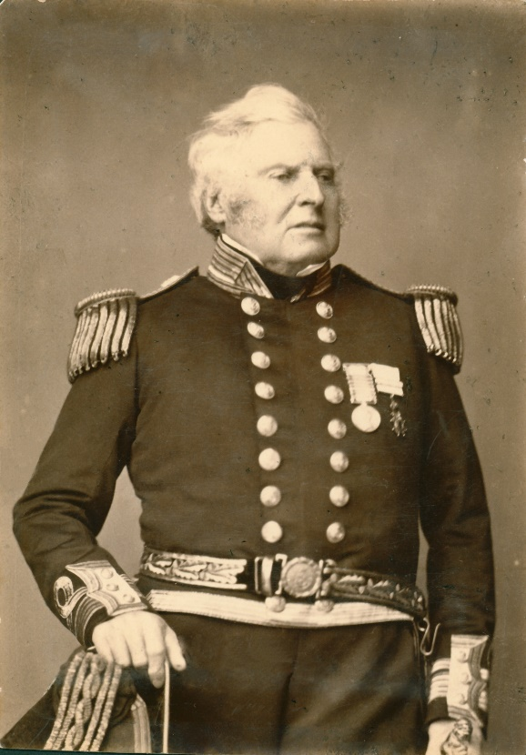
Famous because:
Hindmarsh was the first Governor of South Australia (28 Dec 1836-16 July 1838)
Behind the scenes:
The administration of the colony did not progress at all under the governorship of Hindmarsh. The only progress that was made was the surveying of land by Light and his staff.
Reasons for the lack of progress include:
- Joint authority between Hindmarsh and the powerful and influential resident commissioner, James Hurtle Fischer caused enormous conflict making the administration of the province impossible. Even the most trivial differences between them were elevated to trials of strength.
- Fischer had arbitrary power over the sale of land, was the emigration officer, and the colonial treasurer, enabling him to ignore Hindmarsh.
- Hindmarsh’s authority was continually disputed by mostly disrespectful, inexperienced and/or inefficient officers.
- When it came to appointment of senior staff, preference would be given to those able and willing to buy 5000 acres for every 100 pounds salary they were to receive. Thus ‘commercial and official pursuits in the colony would be not merely tolerated but encouraged’.
- Delays in surveying the land meant possession of land and cultivation was slow.
- Land speculation also absorbed by the early colonist interests and often their funds. Land purchasers would wait for property values to rise and walk away with the profits.
- Hindmarsh also had a tendency to tamper with Light’s instructions and plans for the colony.
- Lack of funds. Hindmarsh’s financial power was limited to Crown revenue which was non –existent from the outset.
- Lack of support from the colonial office.
- Hindmarsh was impatient of opposition and would swear at his officers if his opinions were questioned.
- As a naval officer, Hindmarsh was unsure of particulars of civil/colonial administration
- His actions were also often hasty and ill advised.
In 1838, Hindmarsh recalled to London and Fisher was dismissed.
Why he came to South Australia:
- Hindmarsh applied for, and secured the job of Governor. He was considered a naval officer ‘of merit and character’ and ‘colonial governorships were regarded as suitable rewards for service in the army or navy’.
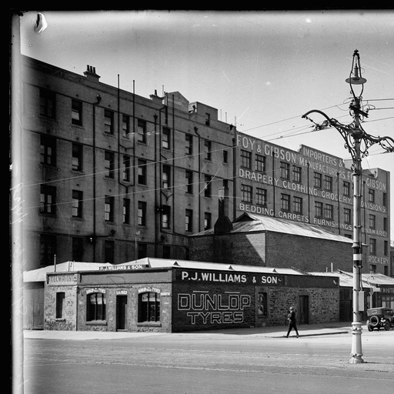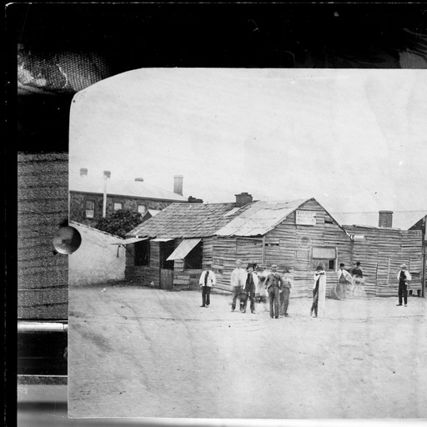  Hindmarsh Square, Adelaide (approximately 1929) Hindmarsh Square (approximately 1860) | Commemoration:  - Hindmarsh Square Adelaide  - Adelaide suburb Hindmarsh  - Hindmarsh Island  - Division of Hindmarsh (electoral division)
References

Primary sources

- The Advertiser (Adelaide, SA 1889-1893, ‘The first governor of Australia’, Mon 28 Jan 1929, p 12 https://trove.nla.gov.au/newspaper/article/35322393 Accessed online 27 March 2018

- The Colonist (Sydney; NSW: 1835-1840) ‘Governor Hindmarsh’, Thursday 5 Oct 1837), p 3 https://trove.nla.gov.au/newspaper/article/31719919

- South Australian Gazette and Colonial Register (Adelaide, SA: 1836-1839) ‘Tyranny of Governor Hindmarsh’, Sat 24 Feb 1838, p 3 https://trove.nla.gov.au/newspaper/article/31719919

- South Australian Gazette and Colonial Register (Adelaide, SA: 1836-1839) ‘Recall of Governor Hindmarsh’, Sat 14 July 1838, p 2 https://trove.nla.gov.au/newspaper/article/31750021

Secondary sources

- J W Bull (1884), Early Experiences of Life in South Australia and an Extended Colonial History, E.S. Wigg and Son, Adelaide SA, eBooks @Adelaide, The University of Adelaide, last updated Feb 2015, https://ebooks.adelaide.edu.au/b/bull/john_wrathall/early-experiences-of-life-in-south-australia/complete.html Accessed online 27 March 2018

- F K Crowley (1974), A New History of Australia, William Heinemann Australia, Victoria

- RM Hague, H Whitington (2005), Hague’s History of the Law in South Australia, Volume 1, Barr Smith Press, University of Adelaide

- A Grenfell Price(1929; 1978), Founders and Pioneers of South Australia, Mary Martin Books, Adelaide

- D Pike (1967), Paradise of Dissent, South Australia 1829-1857, 2nd ed, Melbourne University Press, pp 102-106

- I Radbone and J Robbins (1986) ‘Chapter 14 The history of the South Australian Public Service’ in D Jaensch (ed) The Flinders History of South Australia, Political History, Wakefield Press, Adelaide, pp 448-474.

- R. M. Hartwell (1955) ‘The pastoral ascendancy’ in Australia: A Social and Political History, (ed) G. Greenwood, Angus and Robertson, pp 46-97.

- ‘Hindmarsh, Sir John (1785-1860)’, Australian Dictionary of Biography, National Centre of Biography, Australian National University, http://adb.anu.edu.au/biography/hindmarsh-sir-john-1315 published first in hard copy 1966, accessed online 20 March 2018

- J. Shute (2010) Henry Ayers: The Man, who Became a Rock, B Tauris & Co. Ltd,

John Hindmarsh SLSA [B11165]
Radbone & Robbins (1986), p 449
Hartwell (1955), p75.
Pike (1967) p105
Pike (1967), p 98; Redbone & Robbins (1986), p 448
Shute (2010), p 8
Price (1928, 1978) p 92; Bull (1884)
Price (1928; 1978), p 92
Hindmarsh Square Adelaide 1929 SLSA [B5531] https://collections.slsa.sa.gov.au/resource/B+5531
Hindmarsh Square SLSA [B2482] https://collections.slsa.sa.gov.au/resource/B+2482

