The Nincompoops

according to Mary Lee

Robert Gouger

1802 - 1846
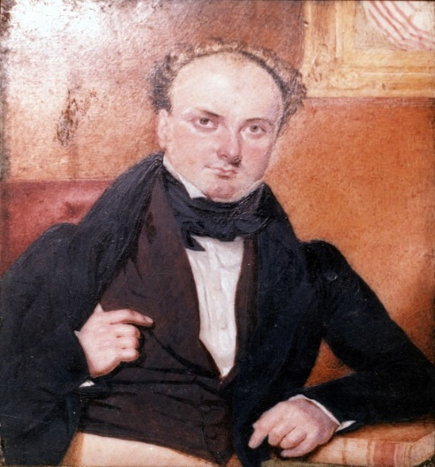
Robert Gouger
Famous because:
Gouger was the first Colonial Secretary of South Australia (1836-1841).
Member of the Legislative Council 28 Dec 1836-22 Aug 1837 and 8 July 1839-16 October 1841)
Behind the scenes:
Gouger spent a short time in Kings Bench prison for bankruptcy in 1829 and while in jail, he learned about discoveries in South Australia.
He visited Wakefield in Negate prison and became a staunch supporter of systematic colonisation. Shortly after his release from prison, he and Wakefield drafted the first proposal to found the colony. The proposal ‘promised rich rewards to speculators who were willing to risk their money at the start of the venture.’ Gouger ‘became Wakefield’s most energetic planner, plotter and propagandist.’
Their partnership prospered despite their different natures. Gouger is described as ‘efficient, single minded and faithfully devoted to any duty undertaken’, while Wakefield is described as ‘capricious, unscrupulous, avid for influence and fame’. The partnership however, ended in 1834 over a disagreement about the price of land.
In 1837, Hindmarsh suspended Gouger from his duties as Colonial Secretary, following a public brawl with Osmond Gilles (the colonial treasurer). Controversy surrounded the suspension of Gouger, rather than both parties. Gouger then left for England to seek redress and his suspension was found not be acknowledged. He was reappointed in1838. In the meantime, Hindmarsh was recalled back to England. Gouger returned to SA and resumed his duties in Feb 1839 under Governor Gawler.
Because of ill health, he was removed from his position as Colonial Secretary on 1841 and appointed Treasurer soon after Grey arrived. He resigned in 1844 following a breakdown and returned to England where he died two years later.
Why he came to South Australia:
Against the English background of high unemployment and congested cities, Gouger advocated Wakefield’s plan of selling land in the colony to provide for the emigration of labour. ‘In many ways, his appointment as first Colonial Secretary was a recognition of a faithful service without which South Australia might never have been settled by systematic colonisers.’

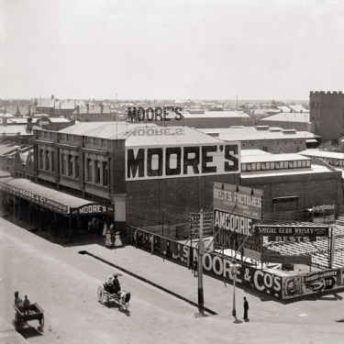  Gouger Street Adelaide (approximately 1911) | Commemoration:  - Gouger Street Adelaide and an electorate. ‘His courage and resolution deserved better memorials’
References

Primary sources
- South Australian Gazette and Colonel Register (Adelaide, SA 1836-1839), Mr Gouger – Ex Colonel Secretary, Sat 3 Feb 1838, https://trove.nla.gov.au/newspaper/article/31749797

- News (Adelaide, SA 1923-1954), Robert Gouger, Father of our State, Mon 29 June 1836, p 4 https://trove.nla.gov.au/newspaper/article/132201556

- The Register (Adelaide, SA: 1901-1929), Robert Gouger: A Founder of State: Manuscripts for Public Library, Sat 21 Feb 1914, https://trove.nla.gov.au/newspaper/article/57183706

- The Sydney Herald (NSW: 1831-1842), South Australia, Mon 20 Nov, 1837,https://trove.nla.gov.au/newspaper/article/28653297
Secondary sources
- D Pike (1967), Paradise of Dissent, South Australia 1829-1857, 2nd ed, Melbourne University Press, pp 98-102

- J M Main (1986) ‘The foundation of South Australia’ in D Jaensch (ed) The Flinders History of South Australia, Political History, Wakefield Press, Adelaide,

- ‘Gouger, Robert (1802-1846)’ Australian Dictionary of Biography, National Centre of Biography, Australian National University, http://adb.anu.edu.au/biography/gouger-robert-2109 published first in hard copy 1966, accessed online 10 April 2018

- G. W. Symes, 'Gilles, Osmond (1788–1866)', Australian Dictionary of Biography, National Centre of Biography, Australian National University, http://adb.anu.edu.au/biography/gilles-osmond-2097/text2641, published first in hardcopy 1966, accessed online 11 December 2018.
Websites
SA government, Former Member of Parliament details, Mr Robert Gouger, https://www2.parliament.sa.gov.au/formermembers/Detail.aspx?pid=4103

Robert Gouger SLSA [B48189]
https://www2.parliament.sa.gov.au/formermembers/Detail.aspx?pid=4103
Main (1986), p 46
Main (1986), p 2
Main (1986), p46
Main (1986) p 2; See also https://trove.nla.gov .au/newspaper/article/132201556
Pike (1967), p 52.
Main (1986), p 2
https://trove.nla.gov.au/newspaper/article/31749797
For example see https://trove.nla.gov.au/newspaper/article/28653297; Gilles was a supporter of Hindmarsh but most of all, he was appointed colonial treasurer ‘partly because of his wealth and his loan for the initial expenses…The Treasury was generally empty, but Gilles kept it going by personal loans, and carried on his land deals and other business activities as well as bickering with his fellows.’ Symes (1966). See also Pike p 108.
https://trove.nla.gov.au/newspaper/article/57183706;
https://trove.nla.gov.au/newspaper/article/132201556; Pike (1967) p 244.
https://trove.nla.gov.au/newspaper/article/57183706
Pike (1967) p99.
Gouger Street Adelaide SLSA [B2187] https://collections.slsa.sa.gov.au/resource/B+2187
Pike (1967) p102

