The Nincompoops

according to Mary Lee

Sir George Grey

1812 - 1898
Sir George Grey
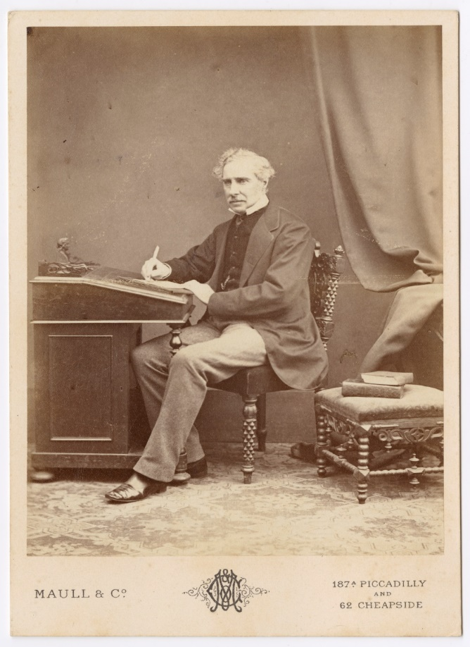
Famous because:
Grey was the third governor of South Australia (1841-1845).
Behind the scenes
- Grey had some experience in colonial administration and had a strong conviction that the colony should live within its means. He would not admit, however, that that the greater parts of his cost cutting measures were made possible by the work of his predecessor, Gawler. For the most part, ‘putting a stop to the mania for building a speculation town’ and directing ‘the energies and exertions of the colonists to agricultural and pastoralists pursuits’, were in process before [his] arrival.
- His ‘greatest achievement was in bringing order and uniformity to the public service…. In each department, fees were increased and staff decreased to the point where it was paying its own way’.
- ‘At heart he was an aristocratic radical with an inordinate pride in his own opinion. His answer to a memorial of a protest on the subject of ‘no taxation without representation’ was “Gentlemen I shall tax you first and you shall be represented afterwards”…he dismissed the memorial as “the clamour of a few turbulent people’ who persisted in trying to prove him “weak enough to be misled by a love of popularity or to be intimidated by threats”.
- Grey did little for the colonists who wanted representative government. He was largely responsible for deferring representative government.
- Rufus Massacre: 27 August 1841 (near the Rufus River and Lake Victoria, NSW)
- ‘Grey began his governorship with a determination to faithfully implement the rule of law set out in the Proclamation, yet within a year, this determination was compromised’.
- ‘With the increase of traffic on the Murray/Darling route from 1838, came private journal reports of pre-emptive Aboriginal shootings. Aboriginal attacks on overlanding parties also became concerted and widespread.’
- Having been petitioned by colonists, Grey reluctantly sanctioned an expedition to escort overlanders (under the leadership of stockman Charles Langhorne), to Adelaide. The expedition was to be led by Major O’Halloran but on conditional terms. It would be accompanied by the Protector of Aborigines (Matthew Moorhouse) whose role was to ‘act as protector and counsel to the natives’ and weapons were only to be used ‘when absolutely necessary’ in ‘self-defence.’ Before the party reached the overlanders, Langhorne’s party and the Maraura had already clashed and 4 of Langhorne’s stockmen were killed. Moorhouse later reported to Grey that Langhorne’s party had shot and killed at least 5 Maraura men though no deaths were mentioned in Langhorne’s report. The police party was then obliged to return to Adelaide.
- In August petitioners again pressed Grey into sending armed forces to the Murray, this time to protect another overland party under the leadership of Robinson. Grey was again reluctant but eventually agreed to endorse a small expedition under the command of Moorhouse, and second in command, Shaw (sub inspector of police). The expedition was meant to be defensive, rather than punitive, and the ‘natives were only to be fired upon in self-defence at the express command of sub-Inspector Shaw’.
- When the Moorhouse/Shaw contingent party met with the Robinson party on 27 August, it was to learn that on the previous day, the overlanders had been attacked and in defending their stock, had killed 5 Aboriginal men and wounded at least another 10 more. Within an hour of the meeting between them they were confronted with a large group of Maraura men, women and children, on the banks of the Rufus River. Fearing imminent attack, Moorhouse gave over command to Shaw. On Shaw’s command both European parties opened fire, followed by the police party from the opposite bank of the river. At least 30 Aboriginal people were killed and many were wounded.
- When the parties returned to Adelaide, Grey called an inquiry into the massacre and the resolution of the Bench of Magistrates was that the party’s actions were necessary and unavoidable for their own self defence and safety. ‘Although the rule of law had observed in this case [unlike the Maria episode] , the final result was that when faced with strong Aboriginal resistance to European incursions, the government again sanctioned and justified the use of deadly forces against people deemed to be British citizens. The outcome on the Rufus River was the largest recorded massacre of Aboriginal people in the colony’s history. ’
- Grey was appointed Governor in New Zealand in 1845. ‘He left his successor with a streamlined civil service staffed in the main by experienced professional officers.’
Why he came to South Australia:
Rumours were going around that Grey ‘ …had deliberately undermined Gawler’s reputation at the Colonial Office by barbed criticism of his lavish administration [and that he] was to be hurried off “in indecent haste” to fill the post of Governor’.
- Commemoration: A South Australian electoral division. Division of Grey.

References

Primary sources
- South Australian Register (Adelaide SA: 1839-1900), ‘Installation of Governor Grey – New government’, Sat 22 May 1841, p 2, https://trove.nla.gov.au/newspaper/article/27442488

- Southern Australian (Adelaide, SA: 1839-1900), ‘His Excellency General Grey on the natives’, Fri 4 June 1841, p 4 https://trove.nla.gov.au/newspaper/article/71614751

- Southern Australian (Adelaide, SA: 1839-1900), ‘Sir George Gipps’ minute on Governor Greys notes on the Aborigines of Australia’, 12 Oct 1841, p. 3 https://trove.nla.gov.au/newspaper/article/71615496

- South Australian Register (Adelaide SA: 1839-1900), ‘Inquiry into the circumstances attending the death of a number of natives on the Murry’, Sat 25 Sept, 1841, p 3 https://trove.nla.gov.au/newspaper/article/27442821

- Papers Relative to South Australia 1843, https://books.google.co.uk/books?id=d3VbAAAAQAAJ&printsec=frontcover#v=onepage&q&f=false
Secondary sources
- R. Foster and A. Nettlelbeck (2012), Out of Silence: The History and Memory of South Australian Wars, Wakefield Press, Adelaide, pp 32- 39 https://books.google.co.uk/books?id=r9ETLG_aKbkC&pg=PA32#v=onepage&q&f=false

- R. Clyne (1982), ‘At war with the natives’ in Insights into South Australian History: Vol 1 Selected articles from the Journal of the Historical Society of South Australia (R. Nicol and B. Samuels eds),( 1992 )Historical Society of South Australia, Adelaide, pp 7-14.

- D. Pike (1967), Paradise of Dissent, South Australia 1829-1857, 2nd ed, Melbourne University Press.

- A. Munyard (1986), ‘Chapter 3 Making a polity ‘in D Jaensch (ed) The Flinders History of South Australia, Political History, Wakefield Press, Adelaide.

- K. Seaman (1986), ‘Chapter 4 the South Australian Constitution Act of 1856’ in D Jaensch (ed) The Flinders History of South Australia, Political History, Wakefield Press, Adelaide.

- I. Radbone and J. Robbins (1986), ‘Chapter 14 The history of the South Australian Public Service’ in D Jaensch (ed) The Flinders History of South Australia, Political History, Wakefield Press, Adelaide, pp 448-474.

- 'Grey, Sir George (1812–1898)', Australian Dictionary of Biography, National Centre of Biography, Australian National University, http://adb.anu.edu.au/biography/grey-sir-george-2125/text2691 , published first in hardcopy 1966, accessed online 21 November 2018.

Sir George Grey SLSA [B73315]
Pike (1967), p 242
Postal charges, fees on land transfers and the registration of deeds, licenses of public houses and auctioneers and port and harbour dues were all increased. A new customs Act added to the existing charges on tobacco and spirits. Pike (1967), p 243.
Pike (1967), p 243
Seaman (1986), p 76-77
This was the usual crossing place of overland parties as well as the scene of the attacks. Clyne (1982) p13
Foster and Nettlebeck (2012), p 32. See also Southern Australian https://trove.nla.gov.au/newspaper/article/71614751
Foster and Nettlebeck (2012), p 35
Foster and Nettlebeck (2012), p 36
Clyne (1982), p 11-13
Clyne (1982), p 13
See South Australian Register https://trove.nla.gov.au/newspaper/article/27442821
Foster and Nettlebeck (2012) p 37.
Radbone and Robbins (1986), p 451
Pike (1967), pp 187-188; See also Munyard (1986,) p 56

