The Nincompoops

according to Mary Lee

Sir Henry Ayers

1821 - 1897
Sir Henry Ayers
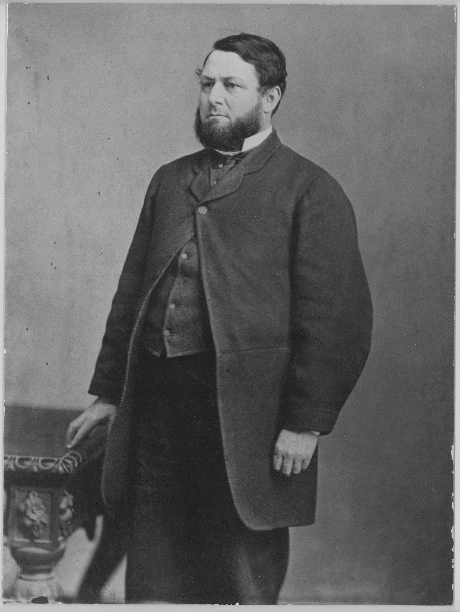
Famous because:
Henry Ayers was the eighth serving premier of South Australia. He was also leader of 7 governments.
In 1857, Ayers was elected into the first South Australian Legislative Council and remained there for over 36 years until 1861, when he was elected President of the Legislative Council until 1893.
Behind the scenes:
The political scene 1857-1893
There were 47 different ministries/governments in 36 years (1857-1893). In the first few decades of political life in South Australia, the government experienced ‘chronic instability’. There were more changes in government in most Australian colonies, than in Britain and self-governing parts of British South Africa or British North America.
Payment of members of parliament was not introduced until 1887. This meant that only those who were employed part time could afford to stand for parliament, ‘or those fortunate enough to be able to retire either with public service pensions or else some capital, acquired after years of thrift and prudent investment.’
Explanations for the constant changes of government include:
There was social prestige being in office and ‘for a considerable section of the members of the House of Assembly’ the constant change ‘‘may be looked upon as chiefly desirous of change for the sake of their personal aggrandizement.”
Entry into the ministry also paved the way for more permanent rewards. Minsters that did not have the hide to withstand the constant sniping from those seeking office, chose to return to their professional or business interests, where they could make more money for similar amounts of labour. ‘In making appointment to the judicial bench, leaders of some ministries, rather than benefit a friend, preferred to get rid of active opponent who was constantly accusing them of ignorance, incapacity and political imbecility.’
‘Unless a minister made some show of playing parish pump, he had a high risk of losing his place in parliament’.
Some governments managed to prolong their existence by dropping unpopular members.
Jessie Ackerman, American journalist and feminist who organised 26 Women’s Christian Temperance Unions in SA during the 1880s, found Australian parliamentarians to be ‘brainless’.…Politics, in short, was the resort of those ambitious individuals who could not achieve anything else.’
Each government department had on average, a change of minister every six months.

Ayers before politics
- Newly married, Ayers emigrated to SA in 1840, at the age of 19 years with his wife and his in-laws. As a lawyer’s clerk, he would not qualify for free passage to SA so conveniently, on his marriage certificate he was registered as a carpenter, which enabled him free passage to SA.
- Ayers secured work as a law clerk in North Terrace shortly after arriving to SA. His arrival ‘coincided with the poorest conditions and prospects that the colony was to know until the threat to its very survival presented by the gold rush in Victoria’.
- Industrious Ayers ‘made the best of his opportunities’ supplementing his income ‘through a sideline supplying law stationary’. He picked up extra pay by ‘overworking. ’ By 1844, he built a house in Pultney St and no longer had to pay rent. He was collecting rent from 3 properties and after paying back debts to his brother and brother in law, he was in a position to lend money. Ayers was using the downturn in the economy to his advantage.
- In 1844, the colony’s fortunes took a turn with the discovery of copper ore at Kapunda and in 1845 in Burra Burra creek. Capitalizing on the Burra Burra finds called for deep pockets and the South Australian Mining Association (SAMA) was formed. Ayers became involved in SAMA in 1845 and he was elected secretary of SAMA. He made his wealth from the Burra Burra Copper Mines (Monster Mines) which secured the wealth of South Australia.
- He was a trustee of the Savings Bank of South Australia for 25 years, a director of the Bank of Australasia, and a founder of the Bank of Adelaide.
- In 1862-97 he was chairman of directors of the South Australian Gas Co. In 1873 he joined the South Australian board of the Australian Mutual Provident Society, later becoming chairman.
- He was governor of the Botanic Gardens Board for thirty-five years and treasurer of the University of Adelaide in 1874-86.
- An Anglican, he gave generously to local charities.
- Ayers was interested in the early settlement of the colony and became the first president of the Old Colonists' Association. In 1891 he published Pioneer Difficulties in Founding South Australia, a lecture given to the Australian Natives' Association.
- He also encouraged exploration of the interior and subscribed to several expeditions

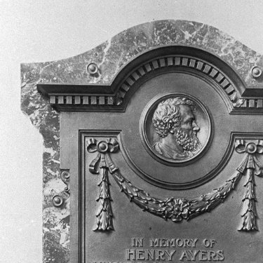  Commemoration tablet for Henry Ayers in Adelaide University (approximately 1900) | Commemoration:  - In 1873, Ayers Rock was named after Henry Ayres by the explorer and surveyor, William Gosse. In 1993, the dual name Ayers Rock/Uluru became official.  - Commemoration tablet in Adelaide University

References

Primary sources
- South Australian Register (Adelaide SA: 1839-1900), ‘The Late Sir Henry Ayers’, Sat 12 June 1897, p 7 https://trove.nla.gov.au/newspaper/article/54496680 accessed 6 February 2018.

- The South Australian Advertiser (Adelaide SA: 1858-1889) (1870) Tues 31 May 1870, p 2 https://trove.nla.gov.au/newspaper/article/28591999 accessed 6 February 2018.

- State Library of South Australia Collections https://collections.slsa.sa.gov.au/resource/B+58685
Secondary sources
- P. A. Howell, (1986) ‘Constitutional and political development, 1857-1890’, in D Jaensch (ed) The Flinders History of South Australia, Political History, Wakefield Press, Adelaide, pp 95-177.

- J. Shute (2010) Henry Ayers: The Man, Who Became a Rock, B Tauris & Co. Ltd.

- S. R. Parr, 'Ayers, Sir Henry (1821–1897)', Australian Dictionary of Biography, National Centre of Biography, Australian National University, http://adb.anu.edu.au/biography/ayers-sir-henry-2914/text4193 , published first in hardcopy 1969, accessed online 13 November 2018.
Websites
- Parliament of South Australia, Premiers of South Australia http://www.parliament.sa.gov.au/Members/FormerMembers/Pages/default.aspx

- NT government (2017), Dual Naming https://placenames.nt.gov.au/policies/dualnaming

Sir Henry Ayers SLSA [B10797]
Howell (1986), p 158; 15 July 1863 - As Premier and Chief Secretary, Ayers formed his own Ministry; 22 July 1864 – 4 Aug 1864 - Ayers Ministry reconstituted; 20 Sept 1865 – 23 Oct 1865 - Defeated because of what he believed was excessive relief for drought stricken northern pastoralist; 3 May 1867 –24 Sept 1868; 13 Oct 1868 – 3 Nov 1868 - Defeated on its land policy; 22 Jan 1872 – 4 March 1872; 4 March 1872 – 22 July 1873 - Reconstruction of ministry.
Howell (1986), p 108; The statistical record of the legislature’s list acknowledges 40 different ministries in this period. Despite its long accepted authority, it only presents part of the picture. Howell (1986), p109.
Howell (1986), p 117
The Register cited in Howell (1986), p 124
Howell (1986), p 125
Howell (1986), p 125
Howell (1986), pp126-127
Parr (1969)
Shute (2010), p 12
Shute (2010), p 12
Group of reasonably well off city shopkeepers who pooled their capital to invest in any newly discovered mineral lands.
Shute (2010), p 15
Parr (1967)
Parr (1967)
Parr (1967)
Commemoration tablet for Henry Ayers in Adelaide University SLSA [B586885] https://collections.slsa.sa.gov.au/resource/B+58685
First white man to ‘discover’ the monolith. Shute (2010), p 1
https://placenames.nt.gov.au/policies/dualnaming

