The Nincompoops

according to Mary Lee

Sir Robert Richard Torrens

1814 - 1884
Sir Robert Richard Torrens

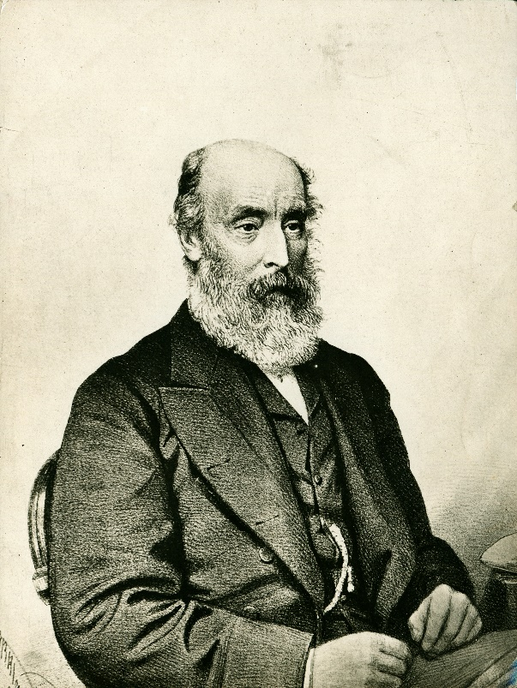
Famous because:
- Premier for South Australia for one month in September 1857.
- Member of the Legislative Council from 1851-1857. ‘…with the adoption of the new democratic constitution, he was elected into the House of Assembly [in 1857]. After his participation in the fall of the Baker government, he was commissioned to form a ministry of his own which was inaugurated in September 1957. Support for Torrens as Premier was only marginal however, and two weeks later, he was defeated in the Lower House on a motion concerning the Waste lands Act and resigned along with his ministry.’
- Better known for sponsoring the Real Property Act 1858 (Torrens Title system) which allowed for the registration of land titles, making the transfer of land a lot more efficient. ‘To a large extent, [the Act]… was a response to dire necessity, itself the product of land speculators greed for gain, plus bureaucratic bungling’. Whether Torrens should be honoured for this much need legal reform is highly contested. The Torrens system was subsequently introduced in other Australian colonies and overseas in the mid 1860’s.
Behind the scenes:
- Sir Robert Torrens arrived in the colony in 1840. From thereon, through the influence of his father, he held high posts in the province’s civil service and ‘he managed to retain these appointments even though he was deplorable administrator, and had been repeatedly censured by all governors from Gawler to MacDonnell. Throughout this period, he was the king of the land-jobbers, making use of insider knowledge – sometimes creating smokescreens of bogus inside knowledge – to speculate successfully on a vast scale. In his orgy of buying, selling and subdividing property, especially land held by widows and absentees, he acquired many titles of very dubious validly’.
- ‘The ideas embodied in the Real Property Act had existed from the beginning of white settlement. A considerable number of colonists had prepared the ground work, awakening public interest, drafting bills, and countering critics from lawyers who foresaw a sharp fall in the income they had been accustomed to receiving from conveyancing. The proposed reform was widely canvassed in the lead up to the March 1857 election and no candidate dared to oppose it publically.’ Hoping to win a seat in the new legislature, Torrens jumped on the bandwagon and joined the land titles registration crusade in 1856.
- In 1857, Torrens stood for Adelaide in the House of Assembly elections of 1857 ‘…and, almost entirely because of his espousal of land titles reform, topped the poll. As treasurer from 24 October 1856 to 21 August 1857, he published a further draft of his bill on 14th and 15th April and introduced it as a private member's bill in yet a third form on 4 June. He was premier from 1 to 30 September, but no action was taken on the Bill until 11 November, when the second reading was carried. Despite very strong opposition, mainly from the legal profession, it passed through both Houses and was assented to on 27 January 1858.’
- ‘The principle embodied in that Act constitutes the most important legal reform that South Australia has ever given to the English speaking world. There was nothing altruistic about it. Reform in land titles was clearly needed…. Constant trading in land, the destruction of government surveying field books and district maps in 1839 made conveyancing slow and expensive after 2 decades of whit immigration ¾ of original deeds were lost while others were defective or seriously complicated. Paper used for the deeds was also fragile and highly susceptible to shrinkage. This made it difficult to tell where boundaries lay …’
- Despite Torrens sponsoring the Real Property Bill, it required such extensive revision and polishing, that his contribution to the ultimate achievement was a very modest one.
- Torrens, ‘did not acknowledge publicly the assistance that he received, but it was his dedication, bordering on zealotry, for 'the Cause' that initiated the Real Property Act in South Australia and the spread of the Torrens system to other Australasian colonies. It has sufficient identifying features to be regarded as an important legal reform that is indigenous to Australia’.
- Torrens had lobbied to the Morgan Ministry to award him a pension in recognition of his role in securing the passage of the Real Property Act. ‘Pandemonium erupted in the Assembly, where it was claimed that Torren’s role had been no more important than anyone else’s. The proposal was dropped after the House insisted that a score or more of those who had helped to get the legislation enacted had at last equal claims to the province’s gratitude.’
- Torrens possessed a unique propensity for arousing animosity and even hatred. He quit parliament in 1858 to accepted appointment as Registrar General and chairman of the Land Titles Board.
- Despite the complaints made about him by six governors in succession, Torrens received knighthood in 1872; but by that stage he had been a member of the imperial parliament.
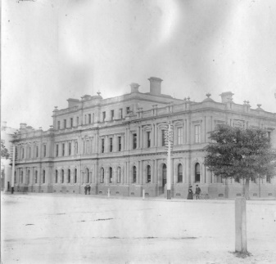  The Torrens Building in Victoria Square (approximately 1905)  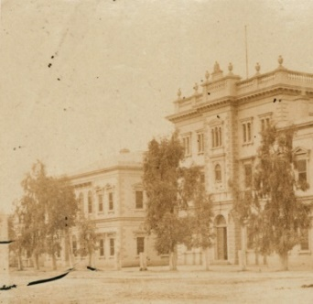  Lands Title Office (approximately 1860) | Commemoration:  - The building which housed the Land’s Title Office in Adelaide, Victoria Square was renamed the Torrens building in 1979. The Heritage listed building is located on the corner of Victoria Square and Wakefield Street.  - Electoral district of Torrens
References
Primary sources
- South Australian Register (Adelaide SA: 1839-1900), ‘Mr Torrens Bill’, Thursday 17 Dec 1957, p, 2 https://trove.nla.gov.au/newspaper/article/49209598

- South Australian Register (Adelaide SA: 1839-1900), Mr Torren’s Real Property Bill’, Sat 23 Jan 1958, p 2, https://trove.nla.gov.au/newspaper/article/49772776

- Border Watch (Mount Gambier, SA: 1861-1954), ‘Sir Robert R Torrens’, Wednesday 4 August 1880, p2 https://trove.nla.gov.au/newspaper/article/77588966
Secondary sources
- P. A. Howell, (1986) ‘Constitutional and political development, 1857-1890’, in D Jaensch (ed) The Flinders History of South Australia, Political History, Wakefield Press, Adelaide, pp 95-177.

- P A Howell (1980), ‘Saints or scoundrels? A reappraisal of some notable Australians, with reflections on related issues’, in Insights into South Australian History: Vol 1 Selected articles from the Journal of the Historical Society of South Australia (R Nicol and B Samuels eds),( 1992 )Historical Society of South Australia, Adelaide, pp 15-22.

- Douglas, J Whalan, ‘Torrens, Sir Richard (1814-1884)’, Australian Dictionary of Biography, National Centre of Biography, Australian National University, http://adb.anu.edu.au/biography/torrens-sir-robert-richard-4739/text7869, published first in hardcopy 1976, accessed online 13 November 2018.
Websites
- SA Government, Former Member of Parliament Details, Sir Robert Torrens GCMG, http://www2.parliament.sa.gov.au/formermembers/Detail.aspx?pid=4012

- SA Government, Torrens Building http://adelaidia.sa.gov.au/places/torrens-building-0

Sir Robert Richard Torrens SASL [ B8411]
From 1 September to 30 September SA Government http://www2.parliament.sa.gov.au/formermembers/Detail.aspx?pid=4012
Responsible government in SA was first launched when the first session of the colony’s first parliament was opened on 22 April 1957 signalled change in role of governor. The colony was now to be ruled by Ministers who held office at the pleasure of SA parliament. Howell p 95
IBID
Enacted in January 1958. Howell p 161.
Howell (1986) p 158.
He was the son of Colonel Robert Torrens, chairman of the Colonization Commission for SA (and in whose honour the River Torrens and Lake Torrens was named)
He arrived in the colony in 1840 and was immediately appointed Customs which he held for at least 1 0 years.
Howell (1986) p 159
Many of the province’s immigrants had come from places where registration had long since made conveyancing a simple and speedy matter Howell (1986) p 159. Further, colonist such as Thomas Wilson, Richard Bullock Andrews, George Fifas Angas, James Hurtle Fisher, Willian Burford, Ulrich Hubbe and Anthony Forster, had long been campaigning for a Land Title Board. It would make conveyancing cheap, , it would have the power to issues certificates of tile, it would meet …and would settle disputes in private instead of people having to go court and fight it out (which was always public). Howell (1980) p 19; Whalan 1976.
Howell p 159.
At the time he was Treasurer. Howell p 159
South Australian Register 1957, https://trove.nla.gov.au/newspaper/article/49209598
Whalan 1976
Howell (1980) p 17.
Howell (1986) p 161
Whalan (1976)
Howell p. 161; Border Watch 1880 https://trove.nla.gov.au/newspaper/article/77588966
Howell p 161
Howell (1980) p 19
The Torrens Building in Victoria Square SLSA [PRG 280/1/5/101] https://collections.slsa.sa.gov.au/resource/PRG+280/1/5/101
Lands Title Office SLSA [B6358] https://collections.slsa.sa.gov.au/resource/B+6358
Howell (1980); SA government http://adelaidia.sa.gov.au/places/torrens-building-0

