Centre of Democracy: support notes for teachers

When you walk in the entrance, direct the students to look at the big picture on the right. Bags may be left here too. Students can sit if they would like. Ensure everyone can see the painting.

Activity 1

Statement of Acknowledgement (Kaurna – Adelaide)

Ask students to identify the traditional custodians of this very land we are standing on. Ask if anyone in the group identifies as Aboriginal. Ensure they feel valued and heard.
Activity 2
Ask students just to spend a few minutes looking at this paining.
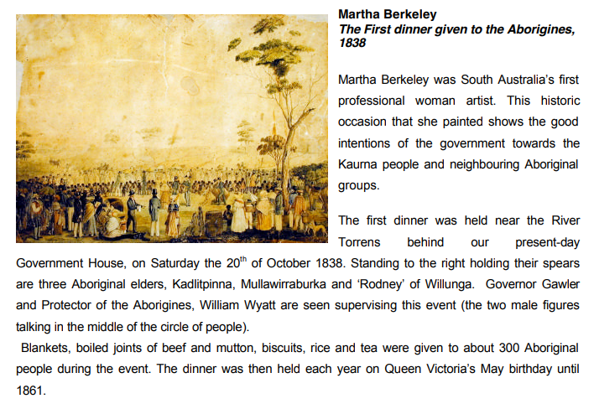
Teacher use these questions as a guide to discuss the painting with the students. Hide the caption to the painting.
What do you think is happening in this painting?
Where do you think this is taking place? When?
Who looks like they are in charge? Why? How?

- Location is the same spot as we are standing. Dinner was held where Government House is today, roughly the same spot as we are now

- Feast provided by Gawler for the Kaurna people to welcome them and they were fed biscuits, baked beef, rice and sweet tea. Between 200-300 Aboriginal people attended and a number of colonists. - Was the food appropriate for the diet of the Aboriginal people (meat, rice and sweet tea)? Who is welcoming who? Who has the right to do so?

- Rugs, blankets, woollen frocks, caps, tin dishes and cups were distributed – getting Aboriginal people to conform to British life, clothed etc

- Fireworks exhibition and bonfire arranged in the evening

- Kaurna were trapped as the receivers of gifts in a system that yielded power and authority to the givers – this set up a mentality that positioned the lives that Aboriginal people have lived was worthless and that they should be grateful for the hand outs and new way of life the British were offering

- Three Kaurna men dressed in European clothing as part of the celebration who were the chosen leaders by the Europeans (Mullawirraburka King John, Kadlitpinna Captain Jack, King Rodney Ityamaiitpinna How were these ’leaders’ chosen? Discuss – The headdress that Governor Gawler is wearing, the feathers have been preserved and are on display in the cabinet opposite where the painting is. Talk about the authority of the uniform and about the power it displayed

- Feast was held in November of 1838, focus on what everyone is wearing and the landscape
- Gawler went off to have his own feast away from this event in a marquee nearby
- Read out the title, unpack it?

This was part of the speech by Governor Gawler
"Black men!
We wish to make you happy. But you cannot be happy unless you imitate white men. Build huts, wear clothes, work and be useful. Above all you cannot be happy unless you love God who made heaven and earth and men and all things. Love white men. Love other tribes of black men. Learn to speak English. If any white man injure you, tell the Protector and he will do justice."
Governor Gawler, 1838

This speech was translated into Kaurna

What are people’s reactions to this? How do you think this may have made people feel? Who looks like they are in charge? What is actually happening?
Activity 3
Hand out the Reflection cards 1 per pair of students, ask students to go off and do a bit of self-guided discovery. Ask them not to hit the button on the Wooden Voting Box as this starts the Time to Vote machine. Allow 5-10 minutes.
Activity 4
Guide students to the big interactive screen and can go through some of the info on there. Watch a couple of people – like Dame Roma Mitchell
Activity 5
Sit students down in front of the Time to Vote machine. Give each students a voting card (on top pf the Wooden Voting Box) Ask a student to press the Wooden Voting Machine button and that will start the Time to Vote video to play. Allow 15 minutes if all three questions are to be voted on.
Question 1. Should Australia federate?
Question 2. Should Australia become a republic?
Question 3. Should drinking hours be extended from 6 pm to 11pm?

Please provide the Centre of Democracy team with feedback and suggestions for improvement.

